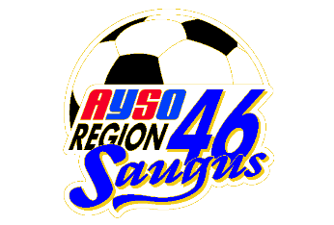
AYSO Region 46

Sportsmanship

ATTENTION ALL COACHES!!

SPORT OF THE YEAR

Every year, one player from each team is recognized as the Sport of the Year. This player is chosen for exhibiting good sportsmanship during the season. Trophies will can be presented to the Sport of the Year at the team's end of season team party.

Please provide the following information about the "Sport of the Year" from your team.

Name
Phone #

Division (G/B): Team Number:

Team Name:

Coach: Coach's Phone No.:

***** PLEASE PRINT ALL INFORMATION LEGIBLY. *****

Be sure the player’s name is spelled correctly!!!

Information due: October 23, 2021
(October 20 for U16/U19)

Please return this form to your Division Rep

Please don’t be late; return the necessary information to assure your player receives a personalized trophy.

